Criterion B: Design

**Basic design**

The product should be easily understandable and and simple for users to interact with, therefore it will have only 3 main tabs. To make it easier for **the client** to understand my vision for the application I created a basic prototype with Adobe Photoshop.

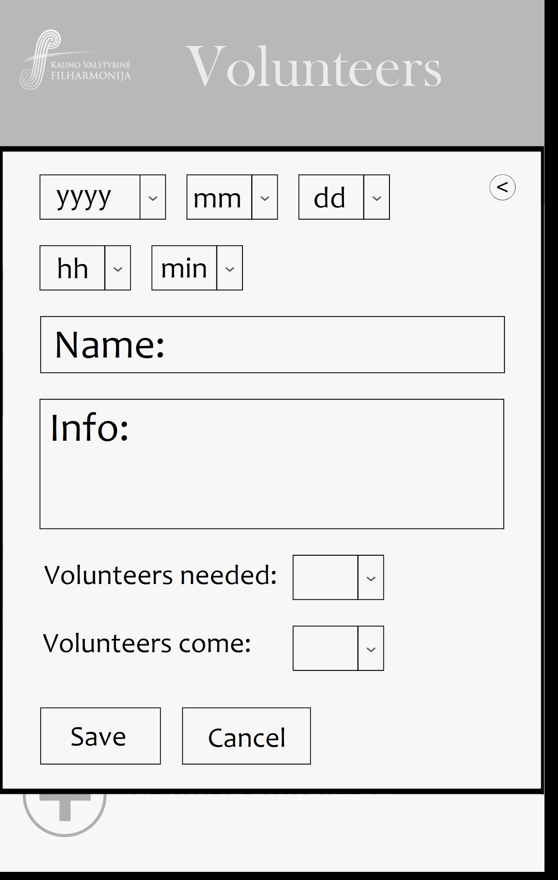 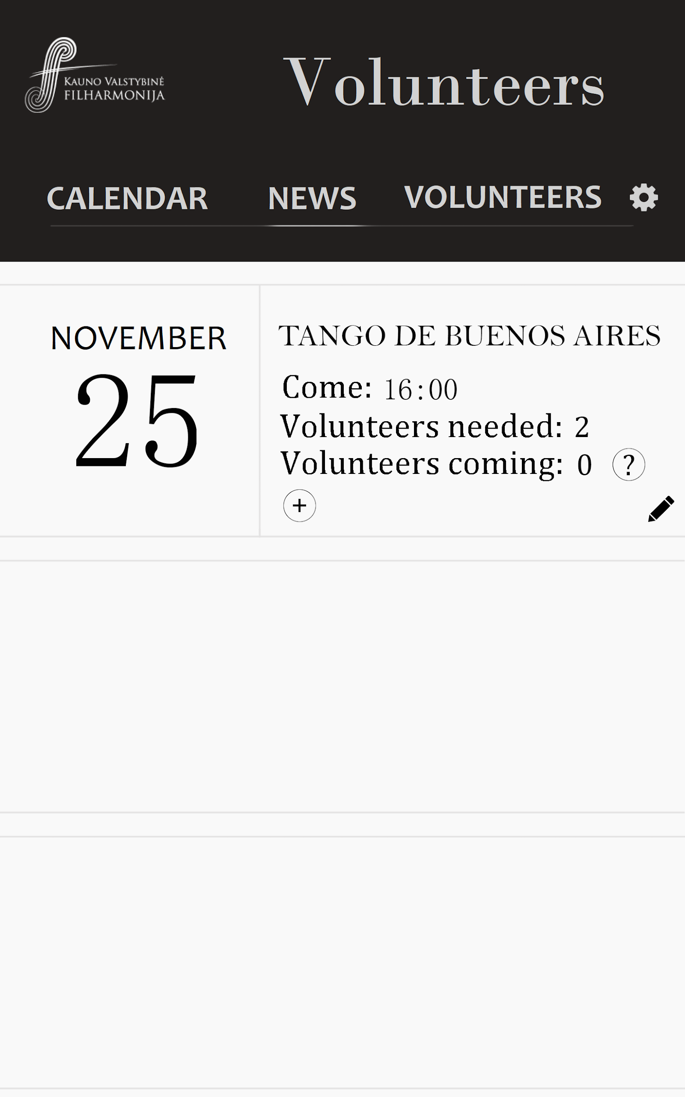

*Figure 1. Creating event screen prototype Figure 2. Event screen prototype.*

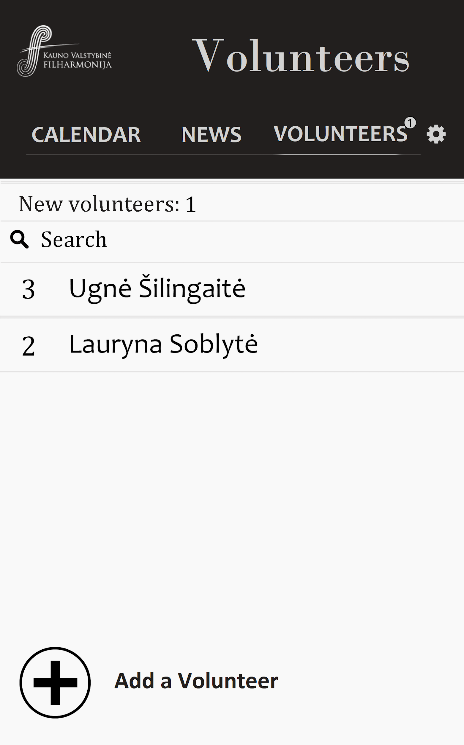 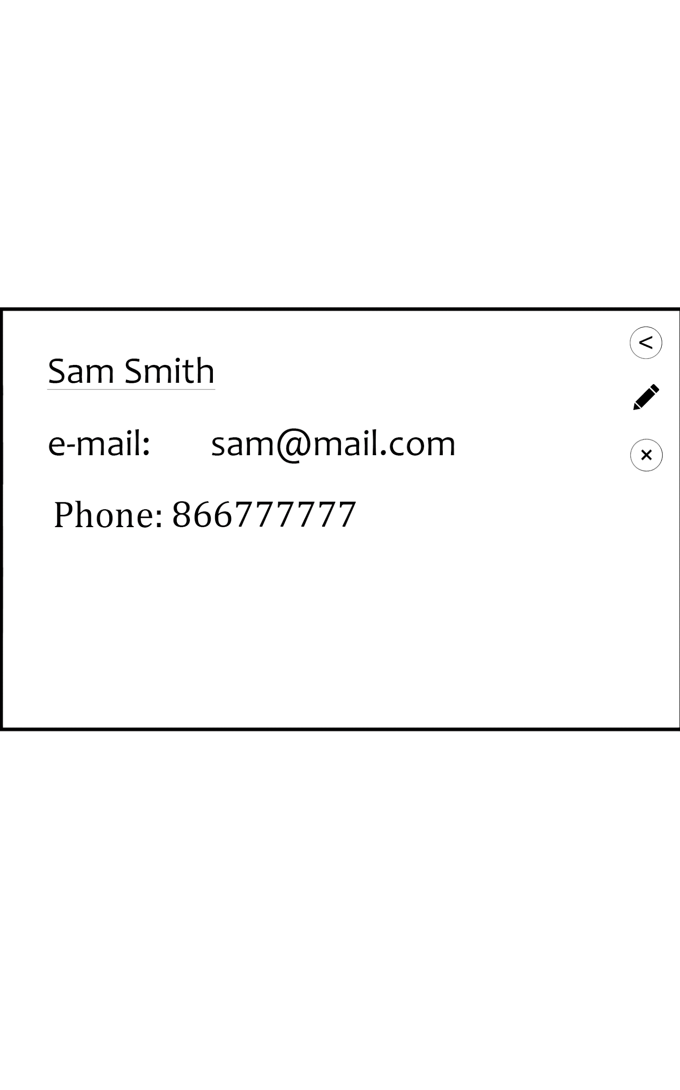

*Figure 3. Volunteer list prototype. Figure 4. User information screen prototype.*

**Diagrams.**

In order to make a project more understandable and draw a clear vision of what I am going to make I created a structure diagram to show the most important parts of the project and show the connection between them.

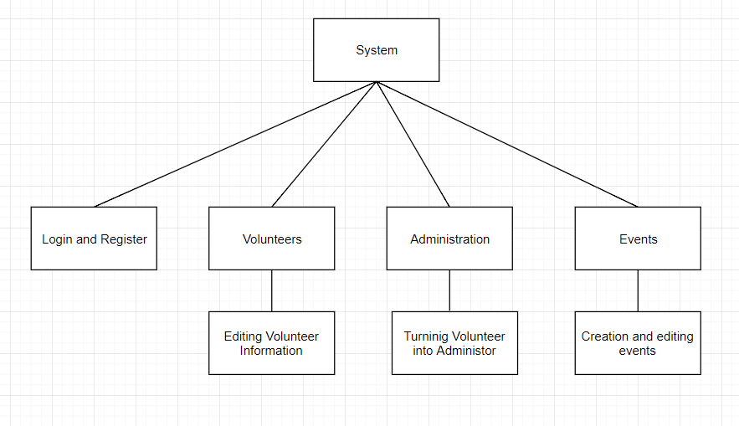

*Figure 5. Structure diagram of the program.*

The program will have multiple objects, therefore UML diagram of the *Eventas* object was made (*Figure 6*).

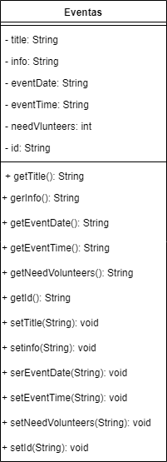

*Figure 6.*

The program will have multiple objects, which will have to be stored in the database.

I made a Database schema in order to show optimise the use of the database and distinguish between the different sections which will be used to store data.

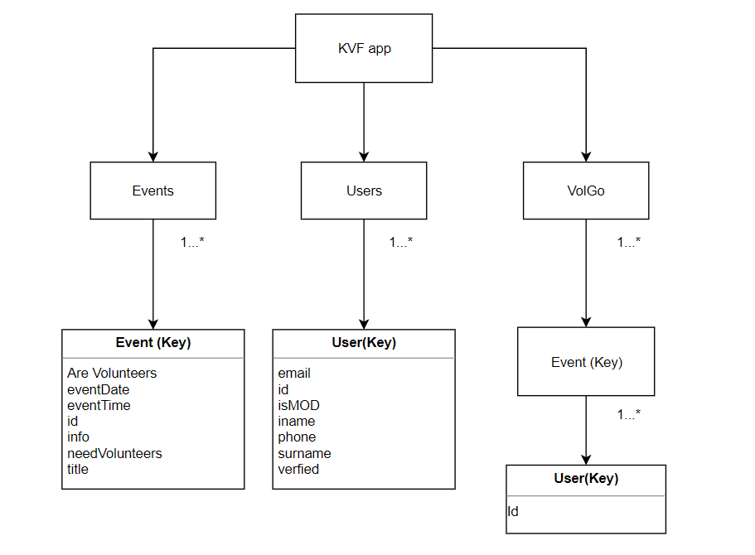

*Figure 7. Database schema of the program*

The data flow in the system is shown by the diagram. The direction of the arrows represents the direction of the data flow.

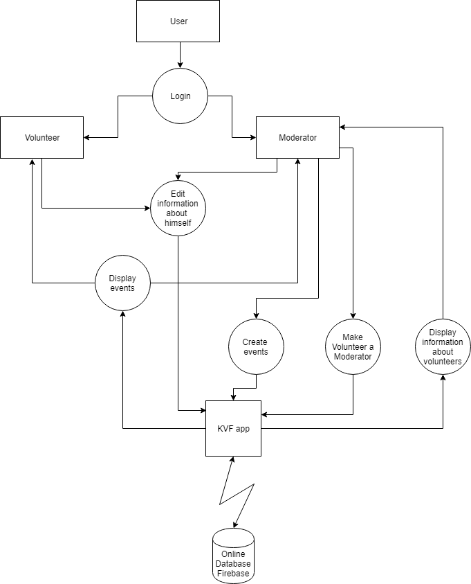

*Figure 8. Data flow diagram of the system.*

**Algorithm**

Since my program needs registration, I made a flowchart diagram representing the algorithm of the registration process.

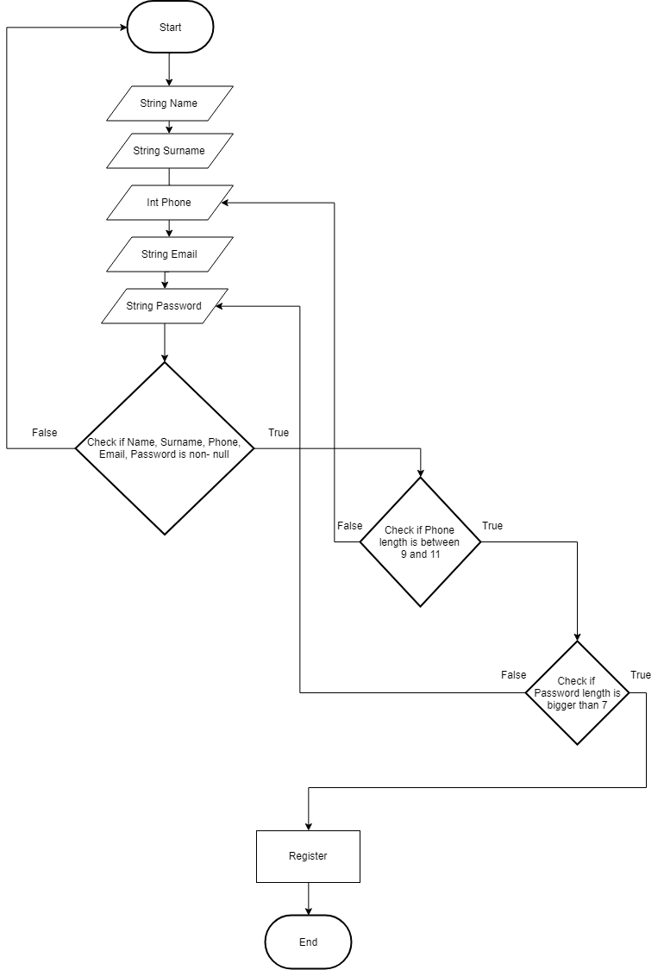

*Figure 9. Flow Chart diagram of the registration algorithm.*

**Testing**

The testing of the program will be performed by Alfa and Beta testing.

* Alfa testing: Each part of the program will be tested by the programmer during the process of production and after the end result is produced.
* Beta testing: Final product will be tested by volunteers, who would actually use the program. According to their feedback and recommendations the program will be modified till the end product satisfies their basic needs.

Client acceptance testing will be used to determine whether the product satisfies the client and is suitable for using.

Testing plan is created in order to perform testing effectively.

| Action | Expected result | Success Criteria |
| --- | --- | --- |
| Going through different tabs | There are only few, yet effective details | 1 |
| Going on the *News* tab | The information about events, such as the time, date, title, information is shown. | 2 |
| Going to the *News* tab | All the data should be sorted by date. | 3 |
| Add several events of the same date | All events appear in the *News* section. | 4a |
| The checkbox *Verify volunteer* is checked | The volunteer should gain access to the volunteer parts of the program, such as check that they are going to the event. | 4b |
| The checkbox *Make a person Moderator*  is checked | The checkbox is gone and the person has Moderator’s abilities | 5a |
| Don’t fill entries in the registration tab during the registration process | The registration should not be completed | 6a |
| In password tab put less than 7 characters during the registration process | The registration should not be completed | 6b |
| The edited information should appear. | The information about the event should be changed. | 7 |

*Table 1. Testing plan.*